

University of Engineering & Technology Mardan
Department of Computer Software Engineering

Submitted By | Umar Hayat
Semester | 6th, Spring 2026
Registration No | 23MDSWE274
Batch | 06
Subject | HCI Lab Task # 02
Submitted To | Dr. Hamid Ullah

Task 1:
1. Design Flaws Identification
- Inefficient Navigation: The horizontal scroll bar is an inappropriate tool for browsing many templates as it lacks "scenting"—the user cannot see what is coming next or how many options exist in total.
- Poor Visibility of System Status: There are no page numbers, labels, or categories to indicate the user's current position within the collection.
- Lack of Comparison: The single-item view prevents users from comparing two styles side-by-side, forcing them to rely on short-term memory.
- Wasted Screen Real Estate: A large portion of the window is occupied by static text instructions on the left, which could have been replaced by a thumbnail gallery.
2. Re-selection Scenario (Memorability)
- Difficulty Level: Extremely High.
- Analysis: If a user wishes to print the same certificate later, they face a high cognitive load. Since there are no unique names or "Recently Used" sections, the user must scroll manually and guess which design matches their previous choice. This violates the HCI principle of Recognition over Recall.
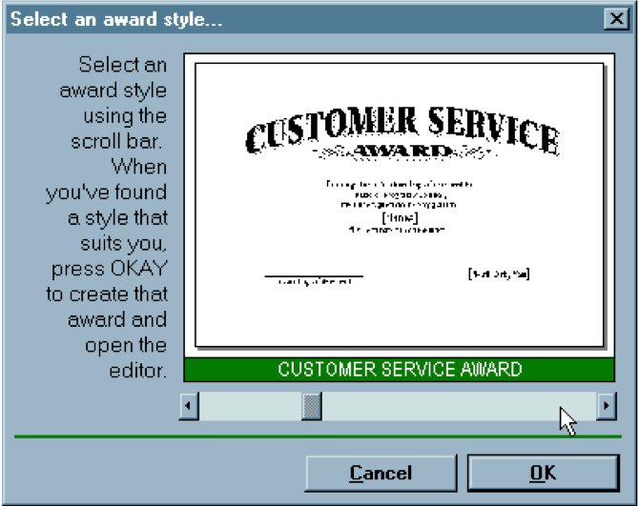

Task 2:
1. Identified Problems
- Redundant Data Entry: Although the user is registered, the system fails to recall the "Callback Phone #" field, forcing manual entry.
- Interaction Glitch (City/Town): In Figure 1.6, the city "Islamabad" appears pre-filled, but the system marks it as invalid. The user is counter-intuitively forced to click the text to trigger a hidden dropdown menu for "validation".
- High Interaction Cost: A registered user must still navigate through multiple dropdowns for City, Branch, and Area instead of the system defaulting to their "Saved" or "Recent" location.

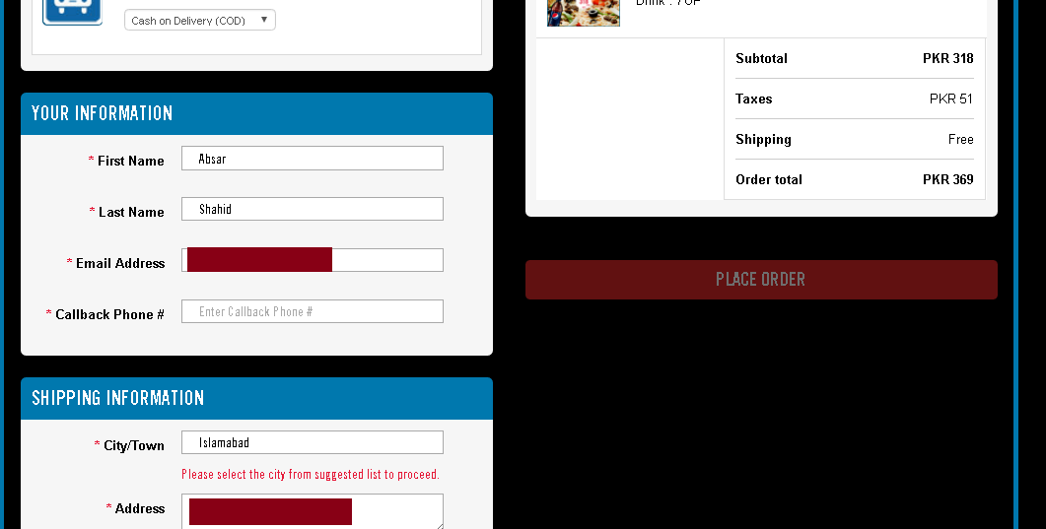

Task 3:
Task: Finding budget-friendly clothes for a five-year-old niece in the "Sales" section.

1. Minnie Minors Evaluation
Observations:
- The website organizes its products using a traditional category structure, such as "Girls," "Boys," "Western," and "Eastern".
- It features a dedicated sales section for budget-conscious shoppers.
Problems Encountered:
- Mixed Age Groups: On the sales landing page, items for infants and older children are often shown together in one long list.
- Filter Difficulty: Because the interface focuses on the type of clothing first, a user looking specifically for "Age 5" has to manually scroll through many irrelevant sizes for babies or teenagers.
- Increased Search Time: Without high-level age filters immediately visible on the main sale page, finding a specific size becomes a tedious "trial and error" process.

2. Hopscotch Evaluation
Observations:
- The user visits the Hopscotch website to perform the same task of finding sale items for a five-year-old.
- The interface utilizes a different navigation logic compared to Minnie Minors.
Comparison Result (Why Hopscotch is Better):
- Age-Centric Navigation: Hopscotch is designed around age groups (e.g., "0-6 Years"), which allows the user to jump straight to the relevant section.
- Efficiency: By filtering out irrelevant sizes right from the start, the user spends less time browsing and more time choosing clothes that actually fit.
- Ease of Use: It is much simpler for a person on a budget to find a bargain when they aren't overwhelmed by products that don't meet their specific needs (like size).

Summary for your Lab Report
Website | Ease of Finding Age 5 | Why?
Minnie Minors | Difficult | Mixes all ages together; requires too much manual filtering.
Hopscotch | Easy | Navigates by age first, making it "age-centric" and faster.

Final Verdict: Hopscotch is better in terms of ease of finding specific items because it reduces the user's effort by organizing products by age rather than just clothing type.

Task 4: University Website Comparison (NUST vs. Harvard)
Task: Comparing the Master's admission process for a local (Pakistan) and international (USA) university.
1. NUST (National University of Sciences & Technology, Pakistan)
- Information Architecture: NUST's website typically features a dense, text-heavy layout where "Postgraduate Admissions" information is nested under multiple layers of menus.
- Admission Workflow Complexity: The process often involves tracking multiple external requirements, such as GAT/HAT entrance tests. The user must often switch between the main site and the admission portal.
- Manual Hurdle: A significant UX barrier is the "Challan" system, which requires students to download, print, and physically deposit fees at a bank, interrupting the digital application flow.
- Cognitive Load: Understanding the "Admission Schedule" requires reading through large tables of dates, which can be overwhelming for a first-time user.
NUST POSTGRADUATE ADMISSIONS PAGE:
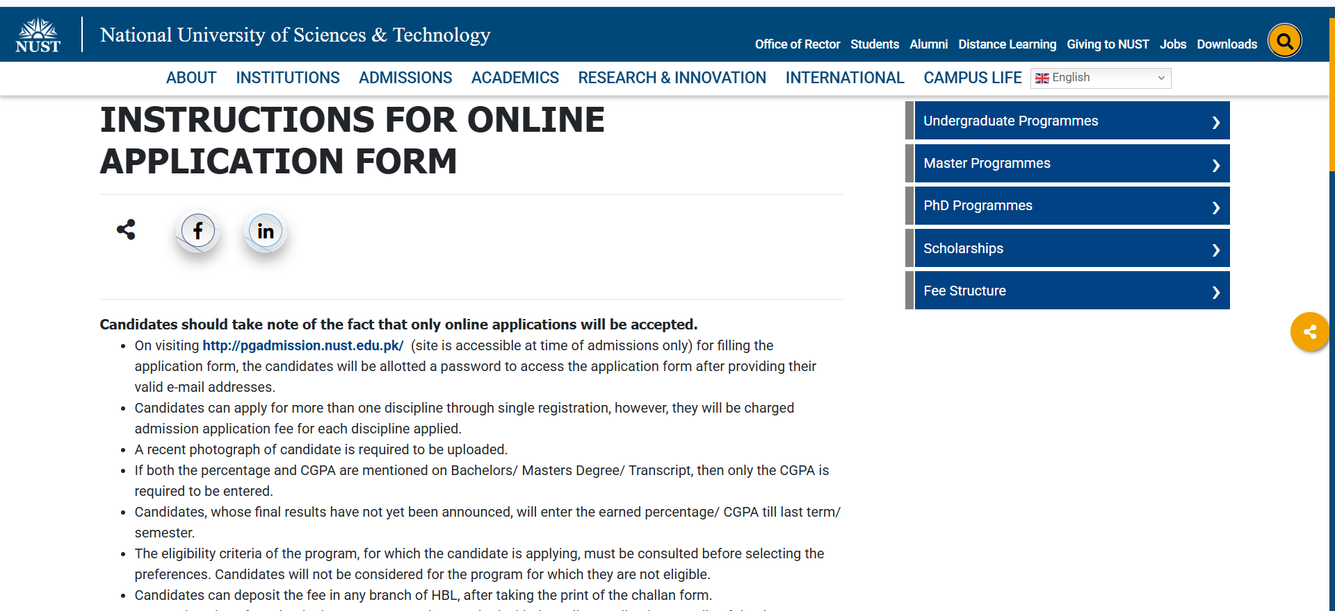

- Link: https://nust.edu.pk/admissions/masters/instructions-for-online-application-form/

2. National University (USA)
- User-Centric Navigation: National University utilizes a highly streamlined, modern interface. The "Admissions" section is prominent and leads immediately to a "Graduate Admissions" hub.
- Visual Roadmap: Instead of long paragraphs, the admission process is presented as a clean, step-by-step guide (e.g., 1. Choose a Program, 2. Submit Application, 3. Connect with an Advisor).
- Integrated Digital Ecosystem: All tasks—from checking specific program requirements to paying fees via credit card—are handled within a single, unified digital portal.
- Simplicity: The design uses a massive amount of "white space" and high-contrast headings, allowing a user to find a specific Master's program deadline in seconds rather than minutes.
NATIONAL UNIVERSITY GRADUATE ADMISSIONS PAGE
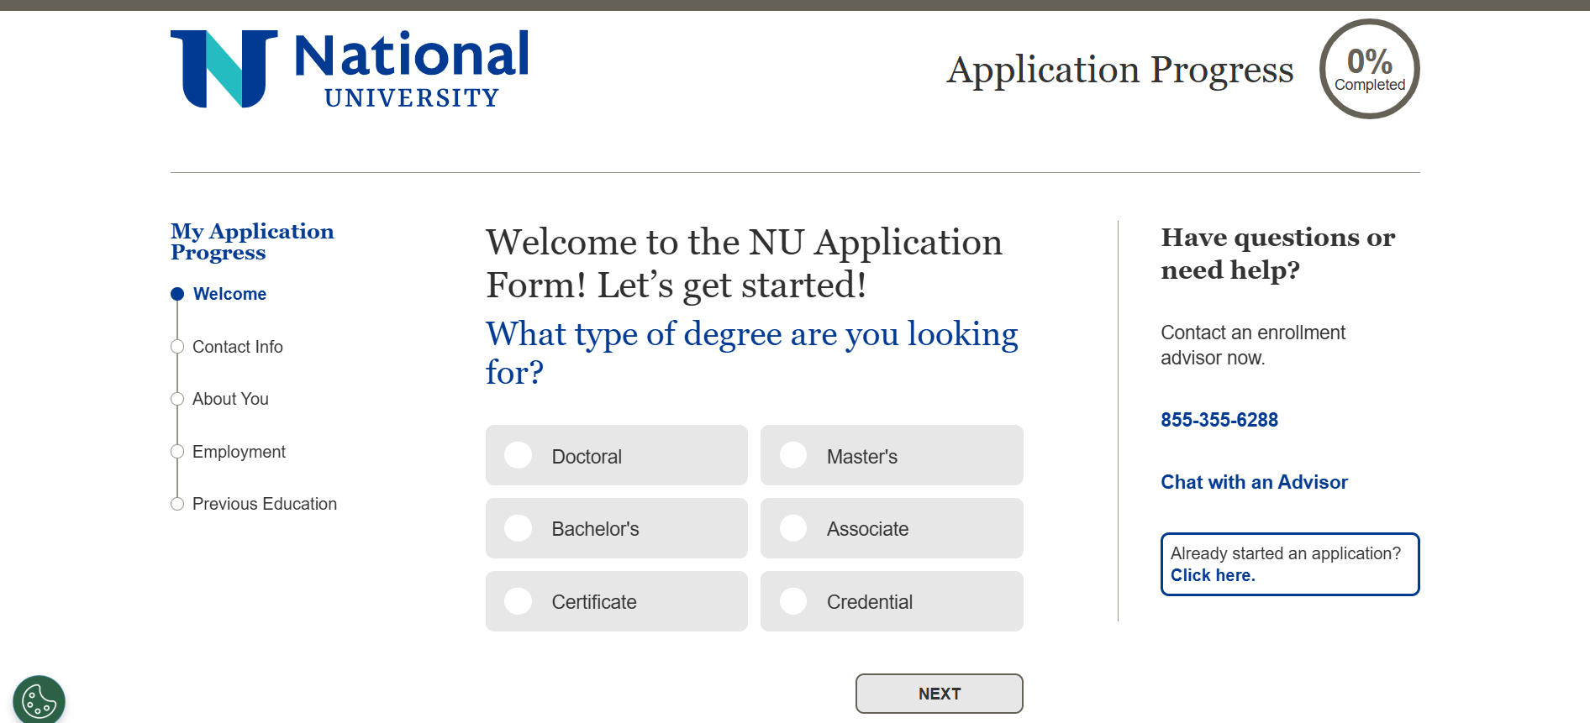

- Link: https://www.nu.edu/admissions/graduate/

3. Comparison Summary and Conclusion
Feature | NUST (Pakistan) | National University (USA)
Information Discovery | Requires navigating multiple links and long text lists. | Highly Intuitive; uses a centralized, modern hub.
Admission Roadmap | List-based and requires tracking external test requirements. | Visual and Linear; provides a clear, guided path.
Transaction Ease | Manual (Bank Challan required). | Digital (Integrated portal and online payment).
Conclusion: In terms of simplicity and understanding the process, National University’s website is superior. It reduces complexity by keeping all necessary tools within a single, visually guided environment. While NUST provides all the necessary information, its more manual and fragmented workflow (Bank Challans and external test sites) makes it harder for a user to quickly grasp the entire process at a glance.

